### **An Ice-Skating Scene Card**

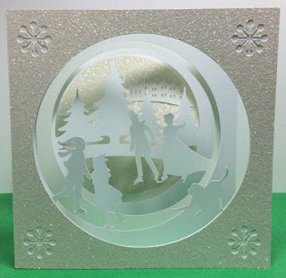

Ice Skating Scene Card

This ice skating card is like a diorama. There are five sections which when folded together create a three dimensional scene. The five sections are glued together by a tab. Each section is numbered in the file to help with the placement.

The construction of this card is the same as the nativity card. <https://papercraftetc.blogspot.com/2018/11/nativity-card-for-christmas.html> The exception is that there is a cover glued to the first scene and the last scene is glued to a backing with a glittered circle glued to the center.

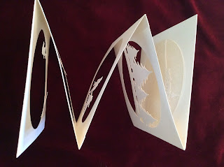

Top view of the card. Notice the zigzag that is formed when the sections are glued together.

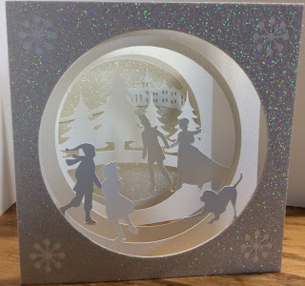

This card would be a beautiful accompaniment to the slice form ice skating snow globe which I made in the previous blog post. <https://papercraftetc.blogspot.com/2019/11/a-sliceform-snow-globe-with-ice-skating.html>